Project Design Phase
Solution Architecture

Date | 06-04-2026
Team ID
Project Name | Smart Library Request Workflow in ServiceNow
Maximum Marks | 4 Marks

Solution Architecture:
The Smart Library Request Workflow in ServiceNow is designed to automate the process of requesting, approving, and managing library books. The architecture integrates user interaction, workflow automation, database management, and notification services to provide an efficient and streamlines system.

Components of the Architecture

1. User Interface (Service Portal)
- Students submit book requests through the portal
- Librarians access and manage requests
- Provides user-friendly interaction

2. Borrow Request Table (Database)
- Stores request details such as book name, user, and status
- Maintains records of all transactions
- Tracks request status (Requested, Approved, Rejected)

3. Flow Designer (Workflow Engine)
- Automates the request process
- Triggers actions based on events
- Controls approval flow and record updates.

4. Approval System
- Sends request to librarian for approval
- Allows approve/reject decision
- Ensures controlled access to books

5. Record Update Mechanism
- Updates book availability status
- Maintains accurate data in the system
- Ensures consistency after approval/rejection

6. Notification System
- Sends email notifications to users
- Informs about request status (approved/rejected)
- Improves communication

7. Reporting Module
- Generates reports like “Most Borrowed Books”
- Provides insights and analytics
- Helps in decision-making

Working Flow
- User submits a book request through the ServiceNow portal
- Request is stored in the Borrow Request table
- Flow Designer triggers the approval process
- Librarian reviews and approves/rejects the request
- System updates the record and book status
- Notification is sent to the user
- Data is used for generating reports

Advantages of the Architecture
- Fully automated workflow
- Reduces manual effort
- Improves accuracy and efficiency
- Provides real-time updates
- Scalable and easy to extend
.

Solution Architecture Diagram:

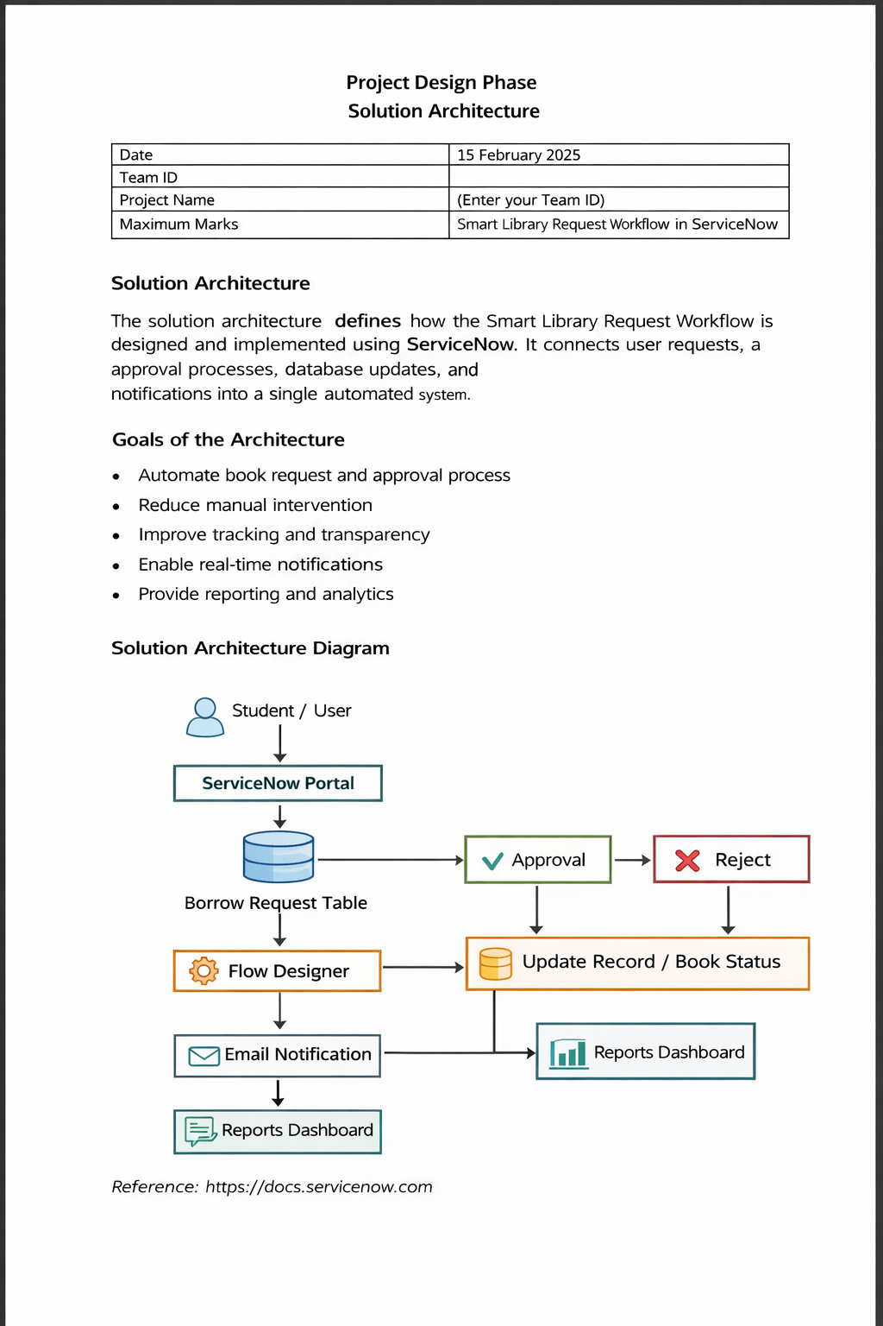

Reference
https://docs.servicenow.com

